

Macintosh HD:Users:benjaminaustin:Downloads:LOGOS:QAComplete_logos_outlines:White version:Horizontal Logo:EPS:SmartBear-QAComplete-White-Horizontal-version_Logo.eps

AlertSite UXM - Monitoring for the connected world.

Your business runs on its applications; which are no longer completely under your control but are dependent on a number of interconnected components to function. APIs connect the components, make calls to web services and databases; if Facebook goes down, your application suffers, if a critical mapping API slows down your business suffers. The world is connected and inter-dependent. You need a solution to pro-actively safeguard your business- you need monitoring designed for the connected world.

AlertSite UXM is a single platform to proactively monitor APIs, mobile, web and SaaS applications, detect problems in end user experience and alert you to them.

AlertSite UXM provides an easy way to:

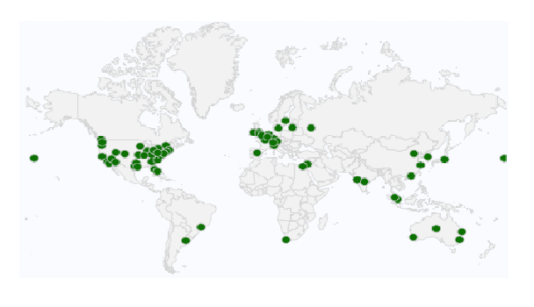

Track Performance and Availability

Monitor APIs, mobile, web and SaaS applications 24X7 from 80+ locations across the globe with proactive synthetic monitoring.

Focus on the End User Experience

Continuously monitor your applications by quickly recording businesses transactions. The Web Recorder records complex user interactions using real browsers, without coding. Advanced performance metrics tell you what the end user experience is like.

Global monitoring network

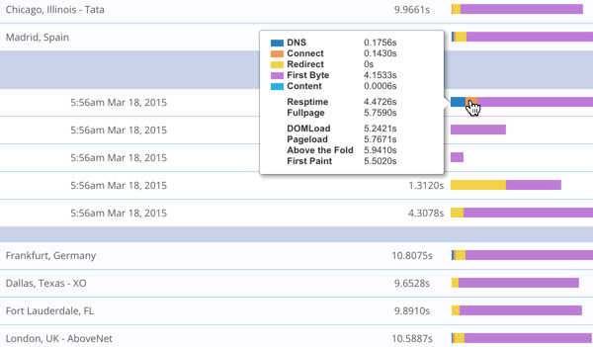

Find Problems before End Users Do

Integration with popular real monitoring solutions brings code level visibility to performance problems. The fastest most accurate alerting on the planet means you know there is a problem before customers do.

Understand 3rd Party Impact

Content delivery networks, third party APIs, site widgets and

Performance metrics

other third party services can slow your application down.

Monitor these services just like your application.

“AlertSite delivered on that initial conversation of being able to show us the performance that the customer sees.”

Jeff Bingaman, Senior Director of IT, Crutchfield

|  |  |  |
| --- | --- | --- |
| Capabilities | | |
| Monitor globally | 24X7 monitoring and 80+ global locations. Know what’s going on anytime anywhere. | |
| Web Recorder &  Real Browser Playback | Real-browser based multistep transaction scripts created with just a few clicks of the mouse. The Alertsite UXM Web Recorder turns your mouse clicks and typing into a performance testing script. Monitor transactions in minutes without any coding. Recorder available using Firefox and Chrome, Playback also available in Internet Explorer | |
| Reuse API functional tests | Integrated with Ready! API. Upload your SOAP and REST functional tests from SoapUI andSoap UI NG Pro | |
| Alerting- get alerts fast without the false positives. | Support for: E-mail, AOL Instant Message (AIM) SMS, Pager, VoIP, POST request to web server, SNMP trap, PagerDuty  Monitor runs a second time on failure, reducing false alarms. | |
| Monitor behind the firewall | Deploy monitoring on a VM or from local desktops to obtain a 360-degree view of performance. Monitor business-critical internal applications, APIs and location specific results otherwise inaccessible over the public Internet. | |
| Monitor these additional services­  ­ | Email | IMAP, POP, SMTP |
| FTP | Server, SSL |
| DNS | DNS­ |
| Server Metrics | CPU memory |

­

**Integrated with: Ready! API, AppDynamics, Pager Duty, Perfecto Mobile**

“With SmartBear AlertSite, we can generate proof as to exactly how well the site is working and what the cause is of any issue—whether it’s within our control or due to outside factors such as the ISP provider, a Web browser, or an internal corporate network.”

*Timothy Rohde, Manager of IT, Grass Roots America*

About SmartBear Software



SmartBear is the choice of more than two million software professionals and over 25,000 organizations in 90 countries that use its products to build and deliver the world’s best software applications. SmartBear’s user-centric application management solutions support key software delivery processes of development, testing, API readiness, and application performance management across desktop, web, and mobile platforms. Get started at [www.smartbear.com](http://www.smartbear.com)